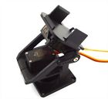**PT Kit Pan/Tilt Camera Platform Anti-Vibration Mount For Servo Aircraft FPV RC**

Feature:

-Two axies platform, anti-vibration.

-Lightweight, won't add weight of the servos and camera.

-Great shape design, production of sophisticated.

-Fits for 9g-12g servos and camera.

-Please notice the camera and servos are not included.

Specifications:

-Material: Plastic + metal

-Net weight 20g.

-Color: Black

Packing Includes:

-1 x Camera Platform

-1 x set screws